Navigating our website to find availability and rates.
- Home Page. Please enter information and Search.
  - Destination
  - travel dates
  - # of travelers
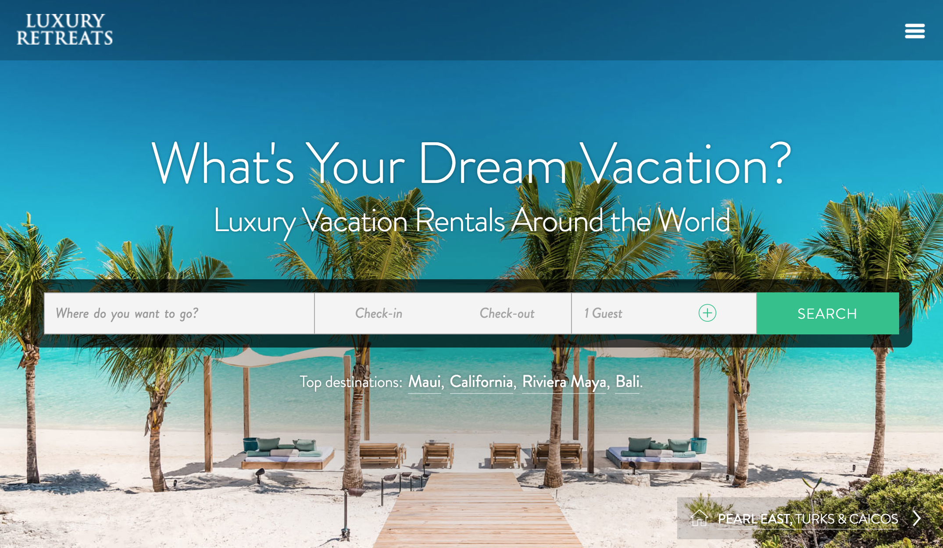

** If destination does not appear, we do not represent this destination. It will look like this:

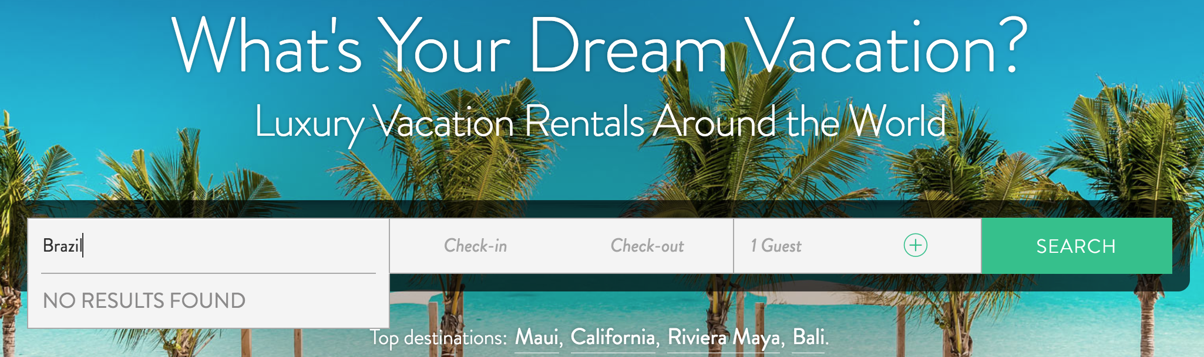

2. Region Pages. All villas showing as available in that region, travel dates and number of guests will show here.
- Not all calendars are LIVE - please ask us when this happens.
- You have the option to sort by Bedrooms, Price and Reviews. (top right)
- The lightning bolt  means the calendars are live and can be booked directly through the website.
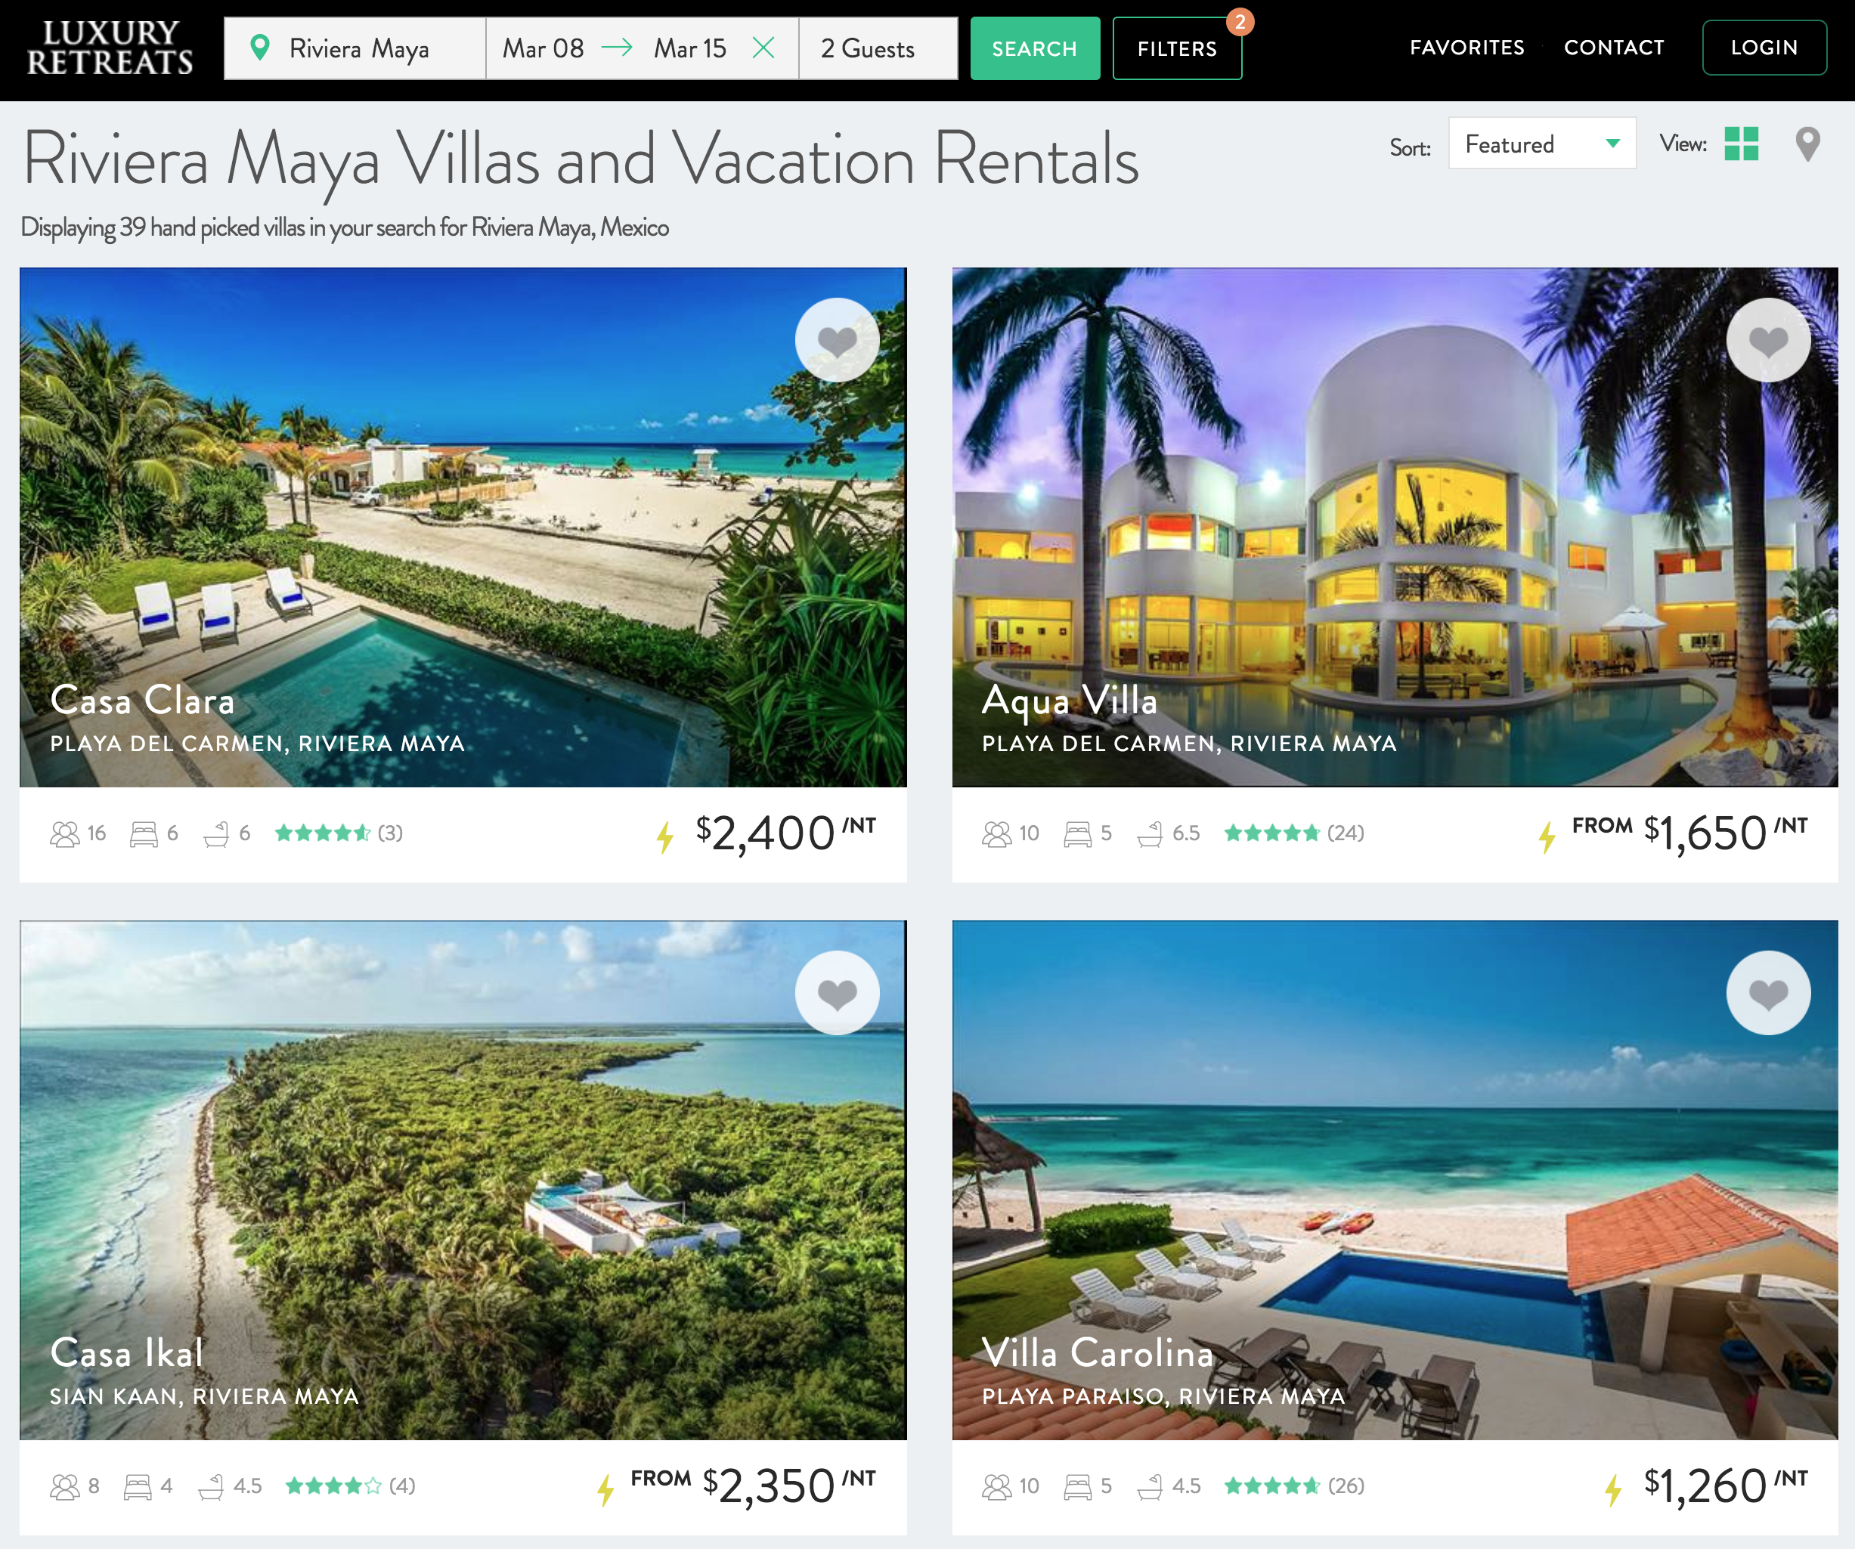

3. Filters. You can refine your search by clicking on the Filter Button on the top of the page. Filters available:
- Price range
- Beachfront
- In the City
- Ski
- Honeymoons - good for 1 or 2 couples
- Large Groups
- Promotion on Villa
- Instabook (the villas with the lightening bolt)
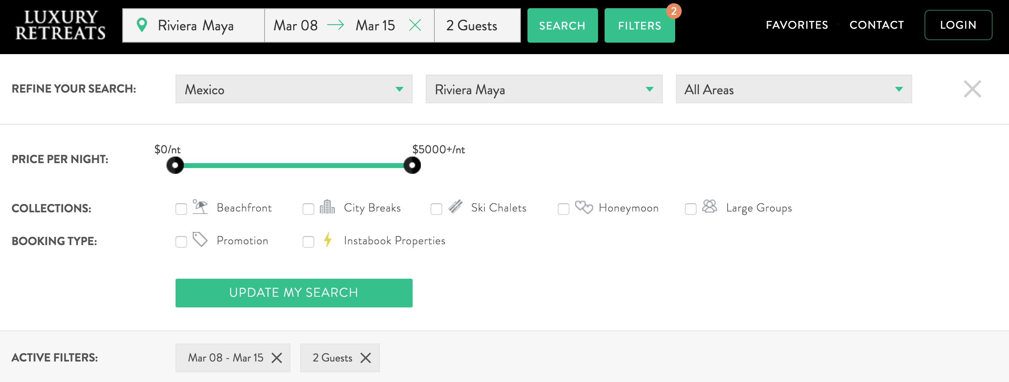

4. Villa Page - When you want to look at a specific property, click on it. It will provide you with a very detailed description of the home. Including:
- Photos
- Rates
- Minimum Night Requirement
- Amenities
- Approximate Location
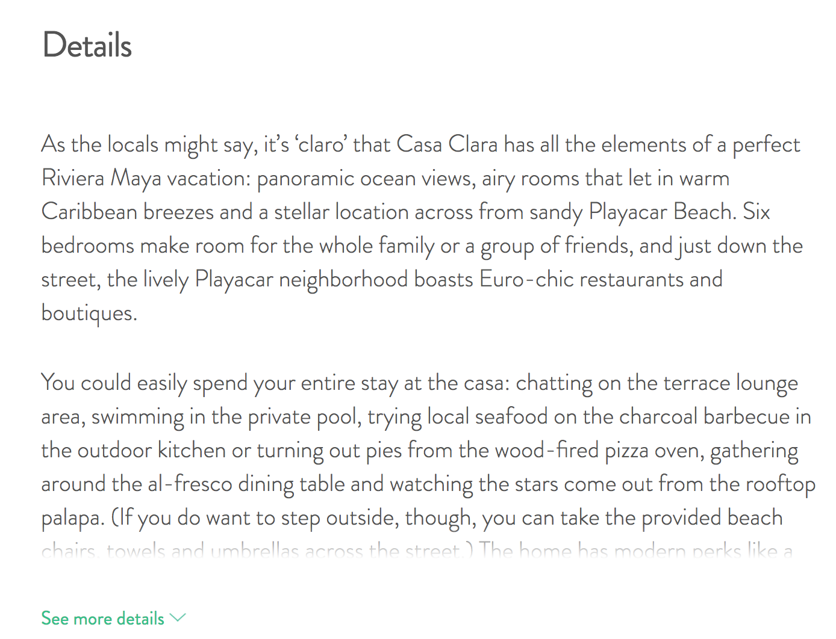
If you scroll down the page and click on “see more details..” It will show you all the features of the house. Indoor, Outdoor, Staff/Services and if they accept events.

Region Information

The Luxury Retreats website includes our full inventory of more than 4000 villas in over 100 destinations.

Right now, the majority of our villas are in the USA (including Hawaii), the Caribbean and Europe.

In 2017, Our Top Requested Destinations:
- Riviera Maya
- California
- Hawaii
- Italy
- Colorado

